**INDEX**

|  |  |  |
| --- | --- | --- |
| **SI.No** | **Name of the Content** | **Page no** |
| **1** | **Synopsis**  **Title**  **Introduction**  **Objective**  **Hardware interface**  **Software interface** |  |
| **2** | **Software Requirement Specification**  **Purpose of the system**  **Scope**  **Overall Description**  **Product perspective**  **Product function**  **General constraints**  **Assumption and dependencies** |  |
| **3** | **System Analysis and Design**  **Dataflow diagram** |  |
| **4** | **Database Diagram**  **Entity Relationship Diagram** |  |
| **5** | **Structure of detailed design**  **Table** |  |
| **6** | **Coding**  **Introduction**  **Programming style** |  |
| **7** | **screenshots** |  |
| **8** | **Conclusion and future enhancement**  **Conclusion**  **Future enhancement** |  |
| **9** | **bibliography** |  |

**Title of the project:**

**Advanced face recognition student attendance management system**

**Introduction of the system**:

**category:**

windows based application

**overview:**

This system is used to take attendance automatically

**Objectives of the system:**

Our objective is to detect faces with the help of web camera.

Our primary goal is to help the teachers improve, organize the Process of track and manage student attendance and absenteeism, additionally we seek to:

* Provide a valuable service for both teachers and students
* Reduce manual process errors by providing automatic and a reliable attendance system uses face recognition technology.
* Produce monthly reports for lectures
* Lectures capability of editing attendance records
* Calculate absenteeism percentage and send reminder message to students
* Easily manageable by school/college and convert in the form of excel sheet
* Avoiding the time losses during class started
* Simplify the leave request and approval process for students and teachers by providing a centralized platform to manage leave applications and approvals.

**Hardware required for the development/implementation:**

* Processor: intel core i3.

AMD Athlon silver 3050U with Radeon graphics 2.3GHZ

* RAM : 8 GB
* Hard disk: 1 TB

**Software required for the development/implementation:**

Operating system: windows 10

❖ Front end: python

❖ Back end: sqlite3

End user:

➤ Student

➤ admin

**Software Requirement Specification (srs)**

**Purpose:**

This Software Requirement Specification (SRS) aims to provide the readers and users information about the system and its functions and specifications.

SRS describes the data, functional and behavioral requirements of the software**.**

**Scope:**

* By implementing the system, it saves the lot of time.
* It provides easy way to use the functionality.

**Definitions:**

* Data-Flow Diagrams (DFD): Way of representing a flow of a data of a process or a system.
* Software Requirement Specifications (SRS): Description of a software system to be developed.

**Overall Description:**

**Product Perspective:**

This project introduces an involuntary attendance marking system, devoid of any kind of interference with the normal teaching procedure. This system eliminates classical student identification such as calling name of the student, or checking respective id cards of the student, which can not only interfere with the ongoing teaching process. In addition, the students have to register in the database to be recognized. The enrolment can be done on the spot through the user-friendly interface.

**Product Function:**

➤ Protect the database of the firm by requiring a correct and registered

username and password.

➤ Provides an option for user to update information.

➤ Display student information in an organized manner for easy

understanding.

**General Constraints:**

The software is designed to run in windows10 and above operating system with python as front end and MYSQL workbench as back end**.**

**Assumptions and dependencies:**

The user should have some basic computer knowledge. They should be trained to handle the features provided by the system. Some of the details are required to be entered by the user and may not be generated automatically.

**3.SYSTEM ANALYSIS AND DESIGN**

**Data Flow Diagram:**

Data Flow Diagrams are commonly used during problem analysis. A DFD shows the flow of data through a system. It views a system as a function that transforms the input into desired outputs. The agent that performs the transformations of data from one state to another is called a process or a bubble. The processes are shown by named circles and data flows are shown by named arrows entering or leaving the bubbles. A rectangle represents a source or sinks and is a net originator or consumer of data**.**

**CONTEXT FLOW DIAGRAM (DFD LEVEL 0):DFD LEVEL 1 ADMIN:**

FACE RECOGNITION

**ADVANCED FACE RECOGNITION STUDENT ATTENDANCE MANAGEMENT SYSTEM**

ATTENDANCE MANAGEMENT

ADMIN

**DDD**  SIGN UP

UPDATE/DELETE

RESET/SEARCH STUDENT DETAILS

FACE RECOGNITION

SEND/RESET

IMPORT/EXPORT ATTENDANCE

**DFD LEVEL 1 STUDENT:**

STUDENT

**DDD**  SIGN UP

STUDENT DETAILS

FACE RECOGNITION

ATTENDANCE

**DATABASE DIAGRAM**

**Entity Relationship Diagram:-**

The entity relationship diagram depicts the various relationship among entities. An entity relationship model is an abstract conceptual representation of structured data. The entity is referring to the thing which we want to store the information. It may be an object with physical existence. A relationship is a named connection or association between entities and is used to relate two or more entities.

**ER DIAGRAM**

**LOGIN**

**MANAGES**

ADMIN

STUDENT

ATTENDANCE

**Structure of Detailed Design**

**Tables:**

The detailed design we decide the internal logic for the module, which implement the given specification. Detailed design is one of the levels of the design process for software items. Detailed designs which is also known as logic designs, involves the internal sign of the module and how the specification of the module can be specified.

**Student table:**

|  |  |  |  |
| --- | --- | --- | --- |
| **Column name** | **Data type** | **description** | **constraints** |
| **User_type** | **Varchr2** | **User type** | **Not null** |
| **department** | **Varchr2** | **Department** | **Not null** |
| **course** | **Varchr2** | **Course** | **Not null** |
| **year** | **Varchr2** | **Year** | **Not null** |
| **semester** | **Varchr2** | **Semester** | **Not null** |
| **Student_id** | **Varchr2** | **Student_id** | **Primety key** |
| **name** | **Varchr2** | **Name** | **Not null** |
| **Email_id** | **Varchr2** | **Email_id** | **Not null** |
| **Phone_no** | **Varchr2** | **Phone_no** | **Not null** |
| **gender** | **Varchr2** | **Gender** | **Not null** |
| **address** | **Varchr2** | **Address** | **Not null** |
| **password** | **Varchr2** | **Password** | **Not null** |
| **Confirm_password** | **Varchr2** | **Confirm_password** | **Not null** |

**Staff table:**

|  |  |  |  |
| --- | --- | --- | --- |
| **Column name** | **Data type** | **description** | **constraints** |
| **User_type** | **Varchr2** | **User type** | **Not null** |
| **Staff_id** | **Varchr2** | **Staff_id** | **Primety key** |
| **name** | **Varchr2** | **Name** | **Not null** |
| **Email_id** | **Varchr2** | **Email_id** | **Not null** |
| **Phone_no** | **Varchr2** | **Phone_no** | **Not null** |
| **gender** | **Varchr2** | **Gender** | **Not null** |
| **address** | **Varchr2** | **Address** | **Not null** |
| **password** | **Varchr2** | **Password** | **Not null** |
| **Confirm_password** | **Varchr2** | **Confirm_password** | **Not null** |

**Attendence table**

|  |  |  |  |
| --- | --- | --- | --- |
| **Column name** | **Data type** | **description** | **constraints** |
| **Attendance_id** | **Integer** | **Attendance id** | **Primety key** |
| **Student_id** | **Varchr2** | **Student id** | **Not null** |
| **name** | **Varchr2** | **Name** | **Not null** |
| **department** | **Varchr2** | **department** | **Not null** |
| **date** | **date** | **Attendance date** | **Not null** |
| **time** | **time** | **time** | **Not null** |
| **status** | **Varchr2** | **status** | **Not null** |

**CODING**

**Introduction**

The goal of programming or coding phase is to translate the design of the system produced during the design phase into code in the given programming language. This phase affects both testing and maintenance profoundly. Thus, the goal is not to simplify the job of programmer, rather the code should be to simplify the job of the tester and maintainer. Having readability and understanding as a clear objective of the coding activity can self-help in proving software that is more maintainable.

**Sample code:**

**Home.py**

from tkinter import*

import tkinter as tk

from tkinter import ttk

from PIL import Image,ImageTk

from tkinter import messagebox

import webbrowser

import py_compile

class attendance_system:

def __init__(self,root):

self.root=root

self.root.geometry("1550x800+0+0")

self.root.title("Attendance System ")

img=Image.open(r"images\image1.jpg")

img=img.resize((1530,130),Image.ANTIALIAS)

self.photoimg=ImageTk.PhotoImage(img)

a_lal=Label(self.root,image=self.photoimg)

a_lal.place(x=0,y=0,width=1530,height=130)

# bg image

bg_img=Image.open(r"images\bg imag1.jpg")

bg_img=bg_img.resize((1530,710),Image.ANTIALIAS)

self.photoimg_bg=ImageTk.PhotoImage(bg_img)

bg_img=Label(self.root,image=self.photoimg_bg)

bg_img.place(x=0,y=130,width=1530,height=710)

#title

titel_lbl=Label(bg_img,text="Attendance of portal",font=("times",35,'bold'),bg='red',fg='yellow')

titel_lbl.place(x=0,y=0,width=1530,height=45)

#creating buttons for attendence

img2=Image.open(r"images\attendance img.jpg")

img2=img2.resize((220,220),Image.ANTIALIAS)

self.photoimg2=ImageTk.PhotoImage(img2)

b1=Button(bg_img,image=self.photoimg2,cursor="hand2",command=attendance)

b1.place(x=150,y=220,width=220,height=220)

b1_lb1=Button(bg_img,text="Attendance",command=attendance,font=("times",15,'bold'),bg='blue',fg='white',cursor="hand1")

b1_lb1.place(x=150,y=410,width=220,height=35)

#creating button for login

img3=Image.open(r"images\login img.jpg")

img3=img3.resize((220,220),Image.ANTIALIAS)

self.photoimg3=ImageTk.PhotoImage(img3)

b2=Button(bg_img,image=self.photoimg3,cursor="hand2",command=login_page)

b2.place(x=650,y=220,width=220,height=220)

b2_lb1=Button(bg_img,text="Login",font=("times",15,'bold'),bg='blue',fg='white',cursor="hand1", command=login_page)

b2_lb1.place(x=650,y=410,width=220,height=35)

#creating button for help desk

img4=Image.open(r"images\help disk img.jpg")

img4=img4.resize((220,220),Image.ANTIALIAS)

self.photoimg4=ImageTk.PhotoImage(img4)

b3=Button(bg_img,image=self.photoimg4,cursor="hand2",command=help_desk)

b3.place(x=1150,y=220,width=220,height=220)

b3_lb1=Button(bg_img,text="Help Desk",font=("times",15,'bold'),bg='blue',fg='white',cursor="hand1",command=help_desk)

b3_lb1.place(x=1150,y=410,width=220,height=35)

def login_page():

url = "login.py" # replace with your HTML file name

webbrowser.open(url, new=2) # open in new tab

def help_desk():

url = "help_desk.py" # replace with your HTML file name

webbrowser.open(url, new=2) # open in new tab

"""def login_page(self):

self.new_window=Toplevel(self.root)

self.app=login_page(self.new_window)"""

def attendance():

url = "attendance.py" # replace with your HTML file name

webbrowser.open(url, new=2)

root=tk.Tk()

object=attendance_system(root)

try:

image = Image.open(r"images\attendence.jpg") # Replace with your JPG path

photo = ImageTk.PhotoImage(image)

root.iconphoto(False, photo)

except FileNotFoundError:

print("Error: Icon file not found.")

except Exception as e:

print(f"Error loading icon: {e}")

root.mainloop()

**Login.py**

from tkinter import*

import tkinter as tk

from tkinter import ttk

from PIL import Image,ImageTk

from tkinter import messagebox

import webbrowser

import sqlite3

con = sqlite3.connect("student.db")

cur=con.cursor()

td = cur.execute("select * from sqlite_master where type='table' and name = 'student'").fetchall()

conn = sqlite3.connect("student.db")

curr=conn.cursor()

tdd = curr.execute("select * from sqlite_master where type='table' and name = 'staff'").fetchall()

class login_page:

def __init__(self,root):

self.root=root

self.root.geometry("1550x800+0+0")

self.root.title("login page")

self.bg=ImageTk.PhotoImage(file=r"images/bg_login.jpg")

lal_bg=Label(self.root,image=self.bg)

lal_bg.place(x=0,y=0,relwidth=1,relheight=1)

#====craeting variables for usserid and password

self.var_user_id=StringVar()

self.var_password=StringVar()

#creating inner frame

frame=Frame(self.root,bg="black")

frame.place(x=610,y=170,width=340,height=500)

img1=Image.open(r"images/login.jpg")

img1=img1.resize((100,100),Image.ANTIALIAS)

self.photoimg1=ImageTk.PhotoImage(img1)

lal_bg=Label(image=self.photoimg1,bg="black",borderwidth=0)

lal_bg.place(x=730,y=175,width=100,height=100)

self.loginlbl=Label(frame,text="Login",font=("time",20,"bold"),fg="white",bg="black")

self.loginlbl.place(x=130,y=100)

# label and text box user name

self.userid=lbl=Label(frame,text="USER ID",font=("times new roman",15,"bold"),fg="white",bg="black")

self.userid.place(x=40,y=155)

self.txtuser=ttk.Entry(frame,font=("times new roman",12,"bold"),textvariable= self.var_user_id)

self.txtuser.place(x=40,y=200,width=250)

# label andf text box for

self.password=lbl=Label(frame,text="PASSWORD",font=("times new roman",15,"bold"),fg="white",bg="black")

self.password.place(x=40,y=250)

self.txtpassword=ttk.Entry(frame,font=("time",12,"bold"),show="*",textvariable=self.var_password)

self.txtpassword.place(x=40,y=300,width=250)

#icon for eyes

open_eye_icon = Image.open(r"images/open_eyes.png")

open_eye_icon=open_eye_icon.resize((20,25),Image.ANTIALIAS)

self.open_eye_icon=ImageTk.PhotoImage(open_eye_icon)

closed_eye_icon = Image.open(r"images/closed.png")

closed_eye_icon=closed_eye_icon.resize((20,25),Image.ANTIALIAS)

self.closed_eye_icon=ImageTk.PhotoImage(closed_eye_icon)

#creating button for toggle button

self.toggle_button = tk.Button(frame, image=self.open_eye_icon, command=self.toggle_password, relief="flat", borderwidth=0)

self.toggle_button.place(x=280,y=300,width=25,height=25)

#====icon for password and login

img2=Image.open(r"images/login.jpg")

img2=img2.resize((25,25),Image.ANTIALIAS)

self.photoimg2=ImageTk.PhotoImage(img2)

lal_icon1=Label(image=self.photoimg2,bg="black",borderwidth=0)

lal_icon1.place(x=620,y=323,width=25,height=25)

#password

img3=Image.open(r"images/password_ico.jpg")

img3=img3.resize((25,25),Image.ANTIALIAS)

self.photoimg3=ImageTk.PhotoImage(img3)

lal_icon2=Label(image=self.photoimg3,bg="black",borderwidth=0)

lal_icon2.place(x=620,y=420,width=25,height=25)

#login button

self.loginButton=Button(frame,text="Login",command=self.login,font=("times new roman",12,"bold"),bd=4,relief=GROOVE,fg="white",bg="darkblue",activeforeground="white",activebackground="gray")

self.loginButton.place(x=140,y=350)

#Register button

self.registerButton=Button(frame,text="New User Register",command=self.registration,font=("times new roman",10,"bold"),borderwidth=0,fg="white",bg="black",activeforeground="white",activebackground="black")

self.registerButton.place(x=10,y=400,width=160)

#forgetbutton

self.forgetButton=Button(frame,text="forget password",command=self.update_fields,font=("times new roman",10,"bold"),borderwidth=0,fg="white",bg="black",activeforeground="white",activebackground="black")

self.forgetButton.place(x=10,y=420,width=160)

def login(self):

# Fetch the student ID and password from the database

userid = cur.execute("select student_id from student where student_id=?", (self.var_user_id.get(),)).fetchone()

passwordid = cur.execute("select password from student where student_id=?", (self.var_user_id.get(),)).fetchone() # Use student_id to find the matching password

userid1 = curr.execute("select staff_id from staff where staff_id=?", (self.var_user_id.get(),)).fetchone()

passwordid1 = curr.execute("select password from staff where staff_id=?", (self.var_user_id.get(),)).fetchone()

# Debugging print statements to see the fetched values

print(userid, passwordid)

if self.txtuser.get() == "" or self.txtpassword.get() == "":

messagebox.showerror("Error", "All fields required")

elif userid1 and passwordid1 and self.txtuser.get() == str(userid1[0]) and self.txtpassword.get() == str(passwordid1[0]):

messagebox.showinfo("Success", "Login successful")

self.details()

elif userid and passwordid and self.txtuser.get() == str(userid[0]) and self.txtpassword.get() == str(passwordid[0]):

messagebox.showinfo("Success", "Login successful")

url = "present.py" # replace with your HTML file name

webbrowser.open(url, new=2)

else:

messagebox.showerror("Invalid", "Invalid User name and Password")

# Commit changes to the database

con.commit()

def registration(self):

url= "registration_admin.py" # replace with your HTML file name

webbrowser.open(url, new=2)

def toggle_password(self):

# Toggle the visibility of the password

if self.txtpassword.cget('show') == '*':

self.txtpassword.config(show='') # Show the password

self.toggle_button.config(image=self.closed_eye_icon) # Switch to closed-eye icon

else:

self.txtpassword.config(show='*') # Hide the password

self.toggle_button.config(image=self.open_eye_icon) # Switch to open-eye icon

def update_fields(self):

self.userid.config(text="User id")

self.password.config(text="New password")

self.loginlbl.config(text="Forget password",font=("times new roman",11,"bold"))

self.loginButton.place_configure(x=140,y=420)

self.loginButton.config(text="save")

self.registerButton.place_forget()

self.forgetButton.place_forget()

#self.loginButton.config(command=update_table)

def update_table():

cur.execute("UPDATE student SET password=? WHERE student_id= ?", (self.txtpassword.get(),self.txtuser.get()))

cur.execute("UPDATE student SET confirm_password=? WHERE student_id= ?", (self.txtpassword.get(),self.txtuser.get()))

con.commit()

messagebox.showinfo("success","student password updated successful ")

print(self.txtpassword.get())

self.password.config(text="password")

self.loginlbl.config(text="Login",font=("time",20,"bold"))

self.loginButton.place_configure(x=140,y=350)

self.registerButton.place_configure(x=10,y=400,width=160)

self.forgetButton.place_configure(x=10,y=420,width=160)

self.loginButton.config(text="login")

self.loginButton.config(command=self.login)

self.loginButton.config(command=update_table)

def details(self):

url = "details.py" # replace with your HTML file name

webbrowser.open(url, new=2)

root=tk.Tk()

object=login_page(root)

try:

image = Image.open(r"images\attendence.jpg") # Replace with your JPG path

photo = ImageTk.PhotoImage(image)

root.iconphoto(False, photo)

except FileNotFoundError:

print("Error: Icon file not found.")

except Exception as e:

print(f"Error loading icon: {e}")

root.mainloop()

**Registration.py**

from tkinter import*

import tkinter as tk

from tkinter import ttk

from PIL import Image,ImageTk

from tkinter import messagebox

import webbrowser

import sqlite3

import re

import cv2

con = sqlite3.connect("student.db")

cur=con.cursor()

td = cur.execute("select * from sqlite_master where type='table' and name = 'student'").fetchall()

if td==[]:

cur.execute("create table student(user_type varchr2,department varchr2,course varchr2,year varchr2,semester varchr2,student_id varchr2 primarykey,name varchr2,email_id varchr2,phone_no number,gender varchr2,address varchr2,password varchar2,confirm_password varchr2)")

#creating staff table

conn = sqlite3.connect("student.db")

curr=conn.cursor()

tdd = curr.execute("select * from sqlite_master where type='table' and name = 'staff'").fetchall()

if tdd==[]:

curr.execute("create table staff(user_type varchr2,student_id varchr2 primarykey,name varchr2,email_id varchr2,phone_no number,gender varchr2,address varchr2,password varchar2,confirm_password varchr2)")

class registration:

def __init__(self,root):

self.root=root

self.root.geometry("1550x800+0+0")

self.root.title("Registration page")

bg_img=Image.open(r"images/bg_registration_img.jpg")

bg_img=bg_img.resize((1550,850),Image.ANTIALIAS)

self.photoimg_bg=ImageTk.PhotoImage(bg_img)

bg_img=Label(self.root,image=self.photoimg_bg)

bg_img.place(x=0,y=0,width=1530,height=850)

titel_lbl=Label(bg_img,text="Registration portel",font=("times",35,'bold'),bg='darkblue',fg='yellow')

titel_lbl.place(x=0,y=0,width=1530,height=55)

#creating text variables

self.user_type = tk.StringVar()

self.user_type.set("student")

self.var_dep=StringVar()

self.var_course=StringVar()

self.var_year=StringVar()

self.var_semester=StringVar()

self.var_std_id=StringVar()

self.var_std_name=StringVar()

self.var_gender=StringVar()

self.var_email=StringVar()

self.var_phone=StringVar()

self.var_address=StringVar()

self.var_password=StringVar()

self.var_confirmpassword=StringVar()

self.email_error_shown = False

self.phone_error_shown = False

#creating frame for registration

frame=Frame(self.root,bg="darkblue")

frame.place(x=550,y=90,width=500,height=680)

#craeting lable frame foe selectging admin and student as well as radio btn

radio_labf=LabelFrame(frame,text="select Admin or student",font=("times new roman",14,'bold'),bg="darkblue",fg="yellow")

radio_labf.place(x=5,y=5,width=490,height=80)

#creatin style to radio button using style class of ttk

style=ttk.Style()

style.configure("TRadiobutton",font=("times new roman",12,'bold'))

style.configure("TRadiobutton",background="darkblue",foreground="yellow")

#radio button

student_radiobtn=ttk.Radiobutton(radio_labf, text="student", value="student",variable=self.user_type,command=self.update_fields)

student_radiobtn.place(x=5,y=2)

admin_radiobtn=ttk.Radiobutton(radio_labf, text="admin", value="admin",variable=self.user_type,command=self.update_fields)

admin_radiobtn.place(x=100,y=2)

#Course details lable frame

self.courselblf=LabelFrame(frame,text="Course Details",font=("times new roman",14,'bold'),bg="darkblue",fg="yellow")

self.courselblf.place(x=5,y=90,width=490,height=150)

#student details

self.student_details_lblf=LabelFrame(frame,text="Student Details",font=("times new roman",14,'bold'),bg="darkblue",fg="yellow")

self.student_details_lblf.place(x=5,y=240,width=490,height=250)

#craeting textbok and lable for course

department_lbl=Label(self.courselblf,text="Department",font=("times new roman",12,'bold'),bg="darkblue",fg="yellow")

department_lbl.place(x=5,y=10)

year_lbl=Label(self.courselblf,text="Session Year",font=("times new roman",12,'bold'),bg="darkblue",fg="yellow")

year_lbl.place(x=5,y=60)

course_lbl=Label(self.courselblf,text="Course",font=("times new roman",12,'bold'),bg="darkblue",fg="yellow")

course_lbl.place(x=260,y=10)

sem_lbl=Label(self.courselblf,text="Semester",font=("times new roman",12,'bold'),bg="darkblue",fg="yellow")

sem_lbl.place(x=260,y=60)

#crearting combobox for all entry

department_comb=ttk.Combobox(self.courselblf,state="readonly",textvariable=self.var_dep,font=("times new roman",10,'bold'))

department_comb["values"]=("Computer Science","Science","Arts","commerce")

department_comb.place(x=100,y=10,width=150)

year_comb=ttk.Combobox(self.courselblf,state="readonly",textvariable=self.var_year,font=("times new roman",10,'bold'))

year_comb["values"]=("2020-21","2021-22","2022-23","2022-24","2024-25","2025-26","2026-27","2027-28","2028-29","2029-30")

year_comb.place(x=100,y=60,width=150)

course_comb=ttk.Combobox(self.courselblf,state="readonly",textvariable=self.var_course,font=("times new roman",10,'bold'))

course_comb["values"]=("BCA","BCOM","BA","BSC")

course_comb.place(x=330,y=10,width=150)

sem_comb=ttk.Combobox(self.courselblf,state="readonly",textvariable=self.var_semester,font=("times new roman",10,'bold'))

sem_comb["values"]=("I","II","III","IV","V","VI")

sem_comb.place(x=330,y=60,width=150)

# adding place holder to combobox

placeholder="Select Option"

department_comb.set(placeholder)

year_comb.set(placeholder)

course_comb.set(placeholder)

sem_comb.set(placeholder)

#==============creating fildes for student details==========

self.id_lbl=Label(self.student_details_lblf,text="Student id",font=("times new roman",12,'bold'),bg="darkblue",fg="yellow")

self.id_lbl.place(x=5,y=10)

self.name_lbl=Label(self.student_details_lblf,text="Name",font=("times new roman",12,'bold'),bg="darkblue",fg="yellow")

self.name_lbl.place(x=220,y=10)

emailid_lbl=Label(self.student_details_lblf,text="Email id",font=("times new roman",12,'bold'),bg="darkblue",fg="yellow")

emailid_lbl.place(x=5,y=60)

phone_lbl=Label(self.student_details_lblf,text="Mobile no",font=("times new roman",12,'bold'),bg="darkblue",fg="yellow")

phone_lbl.place(x=220,y=60)

gender_lbl=Label(self.student_details_lblf,text="Gender",font=("times new roman",12,'bold'),bg="darkblue",fg="yellow")

gender_lbl.place(x=5,y=110)

address_lbl=Label(self.student_details_lblf,text="Address",font=("times new roman",12,'bold'),bg="darkblue",fg="yellow")

address_lbl.place(x=220,y=110)

password_lbl=Label(self.student_details_lblf,text="password",font=("times new roman",12,'bold'),bg="darkblue",fg="yellow")

password_lbl.place(x=5,y=160)

confirm_password_lbl=Label(self.student_details_lblf,text="confirm password",font=("times new roman",12,'bold'),bg="darkblue",fg="yellow")

confirm_password_lbl.place(x=220,y=160)

#=====adding entry box and all to above feilds

self.id_txt=ttk.Entry(self.student_details_lblf,textvariable=self.var_std_id,font=("times new roman",10,'bold'))

self.id_txt.place(x=80,y=10,width=140)

name_txt=ttk.Entry(self.student_details_lblf,textvariable=self.var_std_name,font=("times new roman",10,'bold'))

name_txt.place(x=340,y=10,width=140)

emailid_txt=ttk.Entry(self.student_details_lblf,textvariable=self.var_email,font=("times new roman",10,'bold'))

emailid_txt.place(x=80,y=60,width=140)

emailid_txt.bind("<FocusOut>",self.validate_email_and_phone)

phone_txt=ttk.Entry(self.student_details_lblf,textvariable=self.var_phone,font=("times new roman",12,'bold'))

phone_txt.place(x=340,y=60,width=140)

phone_txt.bind("<FocusOut>",self.validate_email_and_phone)

gender_cobbox=ttk.Combobox(self.student_details_lblf,textvariable=self.var_gender,font=("times new roman",10,'bold'))

gender_cobbox["values"]=("Male","Female","Other")

gender_cobbox.set(placeholder)

gender_cobbox.place(x=80,y=110,width=140)

address_txt=ttk.Entry(self.student_details_lblf,textvariable=self.var_address,font=("times new roman",10,'bold'))

address_txt.place(x=340,y=110,width=140)

password_txt=ttk.Entry(self.student_details_lblf,textvariable=self.var_password,font=("times new roman",10,'bold'))

password_txt.place(x=80,y=160,width=140)

self.confirm_password_txt=ttk.Entry(self.student_details_lblf,textvariable=self.var_confirmpassword,show="*",font=("times new roman",10,'bold'))

self.confirm_password_txt.place(x=340,y=160,width=140)

password_txt.bind("<FocusOut>",self.password_validation)

self.confirm_password_txt.bind("<FocusOut>",self.password_validation)

#icon for eyes

open_eye_icon = Image.open(r"images/open_eyes.png")

open_eye_icon=open_eye_icon.resize((20,25),Image.ANTIALIAS)

self.open_eye_icon=ImageTk.PhotoImage(open_eye_icon)

closed_eye_icon = Image.open(r"images/closed.png")

closed_eye_icon=closed_eye_icon.resize((25,25),Image.ANTIALIAS)

self.closed_eye_icon=ImageTk.PhotoImage(closed_eye_icon)

#creating button for toggle button

self.toggle_button = tk.Button(self.student_details_lblf, image=self.open_eye_icon, command=self.toggle_password, relief="flat", borderwidth=0)

self.toggle_button.place(x=450,y=160,width=25,height=20)

#====adding button take photo ,reset,save

self.take_photoButton=Button(frame,text="Take photo sample",command=self.generate_data_set,font=("times new roman",12,"bold"),bd=4,relief=GROOVE,fg="black",bg="yellow",activeforeground="white",activebackground="gray")

self.take_photoButton.place(x=20,y=520,width=150)

self.saveButton=Button(frame,text="save",command=self.submit_form,font=("times new roman",12,"bold"),bd=4,relief=GROOVE,fg="black",bg="yellow",activeforeground="white",activebackground="gray")

self.saveButton.place(x=180,y=520,width=150)

self.resetButton=Button(frame,text="Reset",command=self.reset,font=("times new roman",12,"bold"),bd=4,relief=GROOVE,fg="black",bg="yellow",activeforeground="white",activebackground="gray")

self.resetButton.place(x=340,y=520,width=150)

def update_fields(self):

user_type = self.user_type.get()

if user_type == "student":

self.name_lbl.config(text="Student Name")

self.id_lbl.config(text="Student id")

self.student_details_lblf.config(text="Student Details")

self.courselblf.place(x=5,y=90,width=490,height=150)

self.student_details_lblf.place(x=5,y=240,width=490,height=250)

self.take_photoButton.place(x=20,y=520,width=150)

self.saveButton.place(x=180,y=520,width=150)

self.resetButton.place(x=340,y=520,width=150)

elif user_type == "admin":

self.name_lbl.config(text="Teachar Name")

self.id_lbl.config(text="Staff Id")

self.student_details_lblf.config(text="Staff Details")

self.courselblf.place_forget()

self.student_details_lblf.place(x=5,y=160,width=490,height=250)

self.take_photoButton.place_forget()

self.saveButton.place(x=80,y=520,width=150)

self.resetButton.place(x=250,y=520,width=150)

#here createa database and table student and staff

def create_student_table(self):

placeholder="Select Option"

if self.var_dep.get()==placeholder or self.var_course.get()==placeholder or self.var_year.get()==placeholder or self.var_semester.get()==placeholder or self.var_std_id.get()=="" or self.var_std_name.get()=="" or self.var_gender.get()==placeholder or self.var_email.get()=="" or self.var_phone.get()=="" or self.var_address.get()=="" or self.var_password.get()=="" or self.var_confirmpassword.get()=="":

messagebox.showinfo("Error","All Field required",parent=self.root)

else:

cur.execute("insert into student values(?,?,?,?,?,?,?,?,?,?,?,?,?)",(self.user_type.get(),self.var_dep.get(),self.var_course.get(),self.var_year.get(),self.var_semester.get(),self.var_std_id.get(),self.var_std_name.get(),self.var_gender.get(),self.var_email.get(),self.var_phone.get(),self.var_address.get(),self.var_password.get(),self.var_confirmpassword.get()))

con.commit()

messagebox.showinfo("success","student details added successful ")

self.reset()

def create_teacher_table(self):

placeholder="Select Option"

if self.var_std_id.get()=="" or self.var_std_name.get()=="" or self.var_gender.get()==placeholder or self.var_email.get()=="" or self.var_phone.get()=="" or self.var_address.get()=="" or self.var_password.get()=="" or self.var_confirmpassword.get()=="":

messagebox.showinfo("Error","All Field required",parent=self.root)

else:

curr.execute("insert into staff values(?,?,?,?,?,?,?,?,?)",(self.user_type.get(),self.var_std_id.get(),self.var_std_name.get(),self.var_gender.get(),self.var_email.get(),self.var_phone.get(),self.var_address.get(),self.var_password.get(),self.var_confirmpassword.get()))

conn.commit()

messagebox.showinfo("success","Staff details added successful ")

self.reset()

#============this fn for save button to save data to database===

def submit_form(self):

user_type = self.user_type.get()

if user_type == "student":

self.create_student_table()

elif user_type == "admin":

self.create_teacher_table()

#==============Reset the all the fildes===================

def reset(self):

placeholder="Select Option"

self.user_type.set("")

self.var_dep.set(placeholder)

self.var_course.set(placeholder)

self.var_year.set(placeholder)

self.var_semester.set(placeholder)

self.var_std_id.set("")

self.var_std_name.set("")

self.var_gender.set(placeholder)

self.var_email.set("")

self.var_phone.set("")

self.var_address.set("")

self.var_password.set("")

self.var_confirmpassword.set("")

# validation for phone and email

def validate_email_and_phone(self, event=None):

if self.var_email.get()!="":

email = self.var_email.get()

# Email validation

email_regex = r'^[a-zA-Z0-9._%+-]+@[a-zA-Z0-9.-]+\.[a-zA-Z]{2,}$'

if not re.match(email_regex, email):

if not self.email_error_shown: # Only show the error once

messagebox.showerror("Error", "Invalid email format!")

#self.email_error_shown = True

# else:

#self.email_error_shown = False # Reset the flag if email is valid

if self.var_phone.get()!="":

phone = self.var_phone.get()

# Phone number validation

phone_regex = r'^[6-9]\d{9}$' # Assumes 10-digit phone numbers starting with 6-9

if not re.match(phone_regex, phone):

if not self.phone_error_shown: # Only show the error once

messagebox.showerror("Error", "Invalid phone number format! Enter a valid 10-digit number.")

# self.phone_error_shown = True

#else:

#self.phone_error_shown = False # Reset the flag if phone is valid

#=====validation for password======

def password_validation(self,event=None):

if self.var_password.get() != self.var_confirmpassword.get():

messagebox.showerror("Error", "Passwords do not match!")

return

def toggle_password(self):

# Toggle the visibility of the password

if self.confirm_password_txt.cget('show') == '*':

self.confirm_password_txt.config(show='') # Show the password

self.toggle_button.config(image=self.closed_eye_icon) # Switch to closed-eye icon

else:

self.confirm_password_txt.config(show='*') # Hide the password

self.toggle_button.config(image=self.open_eye_icon) # Switch to open-eye icon

#=======================generate data set or take photo sample===========

def generate_data_set(self):

try:

cur.execute("select*from student")

myresult=cur.fetchall()

id=0

for x in myresult:

id+=1

#curr.execute("update student set department=?,course=?,year=?,semester=?,student_id=?,name=?,email_id=?,phone_no=?,gender=?,address=?",(self.var_dep.get(),self.var_course.get(),self.var_year.get(),self.var_semester.get(),self.var_std_id.get()==id+1,self.var_std_name.get(),self.var_gender.get(),self.var_email.get(),self.var_phone.get(),self.var_address.get()))

con.commit()

#========================load predifiend data face frintals from opencv====

face_classifier=cv2.CascadeClassifier("haarcascade_frontalface_default.xml")

def face_cropped(img):

gray=cv2.cvtColor(img,cv2.COLOR_BGR2GRAY)

faces=face_classifier.detectMultiScale(gray,1.3,5)

#scaling facter1.3

#minimum neighbor5

for(x,y,w,h)in faces:

face_cropped=img[y:y+h,x:x+w]

return face_cropped

cap=cv2.VideoCapture(0)

img_id=0

while True:

ret,my_frame=cap.read()

if face_cropped(my_frame) is not None:

img_id+=1

face=cv2.resize(face_cropped(my_frame),(450,450))

face=cv2.cvtColor(face,cv2.COLOR_BGR2GRAY)

file_name_path="data/user."+str(id)+"."+str(img_id)+".jpg"

cv2.imwrite(file_name_path,face)

cv2.putText(face,str(img_id),(50,50),cv2.FONT_HERSHEY_COMPLEX,2,(0,255,0),2)

cv2.imshow("Crooped Face",face)

if cv2.waitKey(1)==13 or int(img_id)==30:

break

cap.release()

cv2.destroyAllWindows()

messagebox.showinfo("Result","Generating data set compled!!")

except Exception as es:

messagebox.showerror("error",f"Due To:{str(es)}",parent=self.root)

url = "train.py" # replace with your HTML file name

webbrowser.open(url, new=2)

#==============================================================

root=tk.Tk()

object=registration(root)

try:

image = Image.open(r"images\attendence.jpg") # Replace with your JPG path

photo = ImageTk.PhotoImage(image)

root.iconphoto(False, photo)

except FileNotFoundError:

print("Error: Icon file not found.")

except Exception as e:

print(f"Error loading icon: {e}")

root.mainloop()

**train.py**

import os

import numpy as np

import cv2

from PIL import Image,ImageTk

from tkinter import messagebox

#def train_classifier():

data_dir=("data")

path=[os.path.join(data_dir,file) for file in os.listdir(data_dir)]

faces=[]

ids=[]

for image in path:

img=Image.open(image).convert('L')#gray scale image

imagenp=np.array(img,'uint8')

id=int(os.path.split(image)[1].split('.')[1])

faces.append(imagenp)

ids.append(id)

cv2.imshow("traing",imagenp)

cv2.waitKey(1)==13

ids=np.array(ids)

#=======================tarin the classifier and save===============

clf=cv2.face.LBPHFaceRecognizer_create()

clf.train(faces,ids)

clf.write("classifier.xml")

cv2.destroyAllWindows()

messagebox.showinfo("Result","training datasets completed!!")

**attendance.py**

from tkinter import *

import tkinter as tk

from tkinter import ttk

from PIL import Image, ImageTk

from tkinter import messagebox

import webbrowser

import cv2

import os

import numpy as np

import sqlite3

from time import strftime

from datetime import datetime

class Attendance:

def __init__(self, root):

self.root = root

self.root.geometry("1550x800+0+0")

self.root.title("Attendance Portal")

# Title Label

titel_lbl = Label(root, text="Face Recognition", font=("times", 35, 'bold'), bg='#E75480', fg='Gold')

titel_lbl.place(x=0, y=0, width=1550, height=55)

# Background Image

try:

bg_img = Image.open(r"images/face_img1.jpg")

bg_img = bg_img.resize((785, 800), Image.Resampling.LANCZOS)

self.photoimg_bg = ImageTk.PhotoImage(bg_img)

bg_img_label = Label(self.root, image=self.photoimg_bg)

bg_img_label.place(x=765, y=55, width=785, height=800)

bg_img1 = Image.open(r"images/face_image2.jpg")

bg_img1 = bg_img1.resize((765, 800), Image.Resampling.LANCZOS)

self.photoimg_bg1 = ImageTk.PhotoImage(bg_img1)

bg_img_label1 = Label(self.root, image=self.photoimg_bg1)

bg_img_label1.place(x=0, y=55, width=765, height=800)

except FileNotFoundError:

print("Error: Background image file not found.")

# Attendance Button

self.loginButton = Button(bg_img_label, text="Give Attendance", command=self.face_recog,

font=("times new roman", 12, "bold"), bd=4, relief=GROOVE,

fg="white", bg="darkblue", activeforeground="Gold", activebackground="#E75480")

self.loginButton.place(x=320, y=650)

#=====================attendance==========================

def mark_attendance(self,student_id,name,department):

with open("attend.csv","r+",newline="\n")as f:

mydatalist=f.readlines()

name_list=[]

for line in mydatalist:

entry=line.split((","))

name_list.append(entry[0])

if((student_id not in name_list)):

now=datetime.now()

d1=now.strftime("%d/%m/%y")

dtString=now.strftime("%H:%m:%S")

f.writelines(f"\n{student_id},{name},{department},{dtString},{d1},present")

# ==================================Face Recognition Function======================

def face_recog(self):

def draw_boundary(img, classifier, scalefactor, minneighbors, color, text, clf):

if img is None:

print("Error: No frame captured. Check camera connection.")

return img

gray_image = cv2.cvtColor(img, cv2.COLOR_BGR2GRAY)

features = classifier.detectMultiScale(gray_image, scalefactor, minneighbors)

coord = []

con = sqlite3.connect("student.db")

cur = con.cursor()

for (x, y, w, h) in features:

cv2.rectangle(img, (x, y), (x + w, y + h), (0, 255, 0), 3)

id, predict = clf.predict(gray_image[y:y + h, x:x + w])

confidence = int((100 * (1 - predict / 300)))

con = sqlite3.connect("student.db")

cur=con.cursor()

#cur.execute(f"SELECT name, student_id, department FROM student WHERE student_id={id}")

student_id=cur.execute(f"SELECT student_id FROM student WHERE student_id={id}").fetchone()

name=cur.execute(f"SELECT name FROM student WHERE student_id={id}").fetchone()

department=cur.execute(f"SELECT department FROM student WHERE student_id={id}").fetchone()

result = cur.fetchone()

if confidence > 77:

cv2.putText(img, f"ID: {student_id}", (x, y - 55), cv2.FONT_HERSHEY_COMPLEX, 0.8, (255, 255, 255), 3)

cv2.putText(img, f"Name: {name}", (x, y - 30), cv2.FONT_HERSHEY_COMPLEX, 0.8, (255, 255, 255), 3)

cv2.putText(img, f"Department: {department}", (x, y - 5), cv2.FONT_HERSHEY_COMPLEX, 0.8, (255, 255, 255), 3)

self.mark_attendance(student_id,name,department)

else:

cv2.rectangle(img, (x, y), (x + w, y + h), (0, 0, 255), 3)

cv2.putText(img, "Unknown Face", (x, y - 55), cv2.FONT_HERSHEY_COMPLEX, 0.8, (255, 255, 255), 3)

coord = [x, y, w, h]

#return coord

return img

def recognize(img, clf, faceCascade):

return draw_boundary(img, faceCascade, 1.1, 10, (255, 255, 255), "Face", clf)

faceCascade = cv2.CascadeClassifier("haarcascade_frontalface_default.xml")

clf = cv2.face.LBPHFaceRecognizer_create()

clf.read("classifier.xml")

video_cap = cv2.VideoCapture(0) # Change to 1 if needed

while True:

ret, img = video_cap.read()

if not ret:

print("Error: No frame captured.")

break

img = recognize(img, clf, faceCascade)

cv2.imshow("Welcome to Face Recognition", img)

if cv2.waitKey(1) == 13: # Press Enter to exit

break

video_cap.release()

cv2.destroyAllWindows()

# Initialize the Tkinter Window

root = tk.Tk()

app = Attendance(root)

# Set Application Icon

try:

image = Image.open(r"images/attendence.jpg")

photo = ImageTk.PhotoImage(image)

root.iconphoto(False, photo)

except FileNotFoundError:

print("Error: Icon file not found.")

except Exception as e:

print(f"Error loading icon: {e}")

root.mainloop()

**details.py**

from tkinter import*

import tkinter as tk

from tkinter import ttk

from PIL import Image,ImageTk

from tkinter import messagebox

import webbrowser

import py_compile

import sqlite3

import re

con = sqlite3.connect("student.db")

cur=con.cursor()

td = cur.execute("select * from sqlite_master where type='table' and name = 'student'").fetchall()

if td==[]:

cur.execute("create table student(user_type varchr2,department varchr2,course varchr2,year varchr2,semester varchr2,student_id varchr2 primary key,name varchr2,email_id varchr2,phone_no number,gender varchr2,address varchr2,password varchar2,confirm_password varchr2)")

#creating staff table

conn = sqlite3.connect("student.db")

curr=conn.cursor()

tdd = curr.execute("select * from sqlite_master where type='table' and name = 'staff'").fetchall()

if tdd==[]:

curr.execute("create table staff(user_type varchr2,student_id varchr2 primarykey,name varchr2,email_id varchr2,phone_no number,gender varchr2,address varchr2,password varchar2,confirm_password varchr2)")

class details:

def __init__(self,root):

self.root=root

self.root.geometry("1550x800+0+0")

self.root.title("Attendance portel")

titel_lbl=Label(root,text="Student details ",font=("times",35,'bold'),bg='Dark Magenta',fg='Gold')#e75480 is color dark pink

titel_lbl.place(x=0,y=0,width=1550,height=55)

bg_img=Image.open(r"images\mainpage_details.jpg")

bg_img=bg_img.resize((1550,800),Image.ANTIALIAS)

self.photoimg_bg=ImageTk.PhotoImage(bg_img)

bg_img=Label(self.root,image=self.photoimg_bg)

bg_img.place(x=0,y=55,width=1550,height=800)

#===================creating text variables

self.user_type = tk.StringVar()

self.user_type.set("student")

self.var_dep=StringVar()

self.var_course=StringVar()

self.var_year=StringVar()

self.var_semester=StringVar()

self.var_std_id=StringVar()

self.var_std_name=StringVar()

self.var_gender=StringVar()

self.var_email=StringVar()

self.var_phone=StringVar()

self.var_address=StringVar()

self.var_password=StringVar()

self.var_confirmpassword=StringVar()

#====================frame 2================================

frame=Frame(self.root,bg="darkblue")

frame.place(x=5,y=60,width=1600,height=720)

#====================framr1 ====================================

frame1=LabelFrame(self.root,bg="darkblue",text="student details",font=("times new roman",14,'bold'),fg="yellow")

frame1.place(x=5,y=60,width=550,height=720)

frame2=LabelFrame(self.root,bg="darkblue",text="student details",font=("times new roman",14,'bold'),fg="yellow")

frame2.place(x=600,y=60,width=900,height=720)

radio_labf=LabelFrame(frame1,text="select Admin or student",font=("times new roman",14,'bold'),bg="darkblue",fg="yellow")

radio_labf.place(x=5,y=5,width=490,height=80)

#creatin style to radio button using style class of ttk

style=ttk.Style()

style.configure("TRadiobutton",font=("times new roman",12,'bold'))

style.configure("TRadiobutton",background="darkblue",foreground="yellow")

#radio button

student_radiobtn=ttk.Radiobutton(radio_labf, text="student", value="student",variable=self.user_type,command=self.update_fields)

student_radiobtn.place(x=5,y=2)

#admin_radiobtn=ttk.Radiobutton(radio_labf, text="admin", value="admin",variable=self.user_type,command=self.update_fields)

#admin_radiobtn.place(x=100,y=2)

#Course details lable frame

self.courselblf=LabelFrame(frame1,text="Course Details",font=("times new roman",14,'bold'),bg="darkblue",fg="yellow")

self.courselblf.place(x=5,y=90,width=490,height=150)

#student details

self.student_details_lblf=LabelFrame(frame1,text="Student Details",font=("times new roman",14,'bold'),bg="darkblue",fg="yellow")

self.student_details_lblf.place(x=5,y=240,width=490,height=250)

#craeting textbok and lable for course

department_lbl=Label(self.courselblf,text="Department",font=("times new roman",12,'bold'),bg="darkblue",fg="yellow")

department_lbl.place(x=5,y=10)

year_lbl=Label(self.courselblf,text="Session Year",font=("times new roman",12,'bold'),bg="darkblue",fg="yellow")

year_lbl.place(x=5,y=60)

course_lbl=Label(self.courselblf,text="Course",font=("times new roman",12,'bold'),bg="darkblue",fg="yellow")

course_lbl.place(x=260,y=10)

sem_lbl=Label(self.courselblf,text="Semester",font=("times new roman",12,'bold'),bg="darkblue",fg="yellow")

sem_lbl.place(x=260,y=60)

#crearting combobox for all entry

department_comb=ttk.Combobox(self.courselblf,state="readonly",textvariable=self.var_dep,font=("times new roman",10,'bold'))

department_comb["values"]=("Computer Science","Science","Arts","commerce")

department_comb.place(x=100,y=10,width=150)

year_comb=ttk.Combobox(self.courselblf,state="readonly",textvariable=self.var_year,font=("times new roman",10,'bold'))

year_comb["values"]=("2020-21","2021-22","2022-23","2022-24","2024-25","2025-26","2026-27","2027-28","2028-29","2029-30")

year_comb.place(x=100,y=60,width=150)

course_comb=ttk.Combobox(self.courselblf,state="readonly",textvariable=self.var_course,font=("times new roman",10,'bold'))

course_comb["values"]=("BCA","BCOM","BA","BSC")

course_comb.place(x=330,y=10,width=150)

sem_comb=ttk.Combobox(self.courselblf,state="readonly",textvariable=self.var_semester,font=("times new roman",10,'bold'))

sem_comb["values"]=("I","II","III","IV","V","VI")

sem_comb.place(x=330,y=60,width=150)

# adding place holder to combobox

placeholder="Select Option"

department_comb.set(placeholder)

year_comb.set(placeholder)

course_comb.set(placeholder)

sem_comb.set(placeholder)

#==============creating fildes for student details==========

self.id_lbl=Label(self.student_details_lblf,text="Student id",font=("times new roman",12,'bold'),bg="darkblue",fg="yellow")

self.id_lbl.place(x=5,y=10)

self.name_lbl=Label(self.student_details_lblf,text="Name",font=("times new roman",12,'bold'),bg="darkblue",fg="yellow")

self.name_lbl.place(x=220,y=10)

emailid_lbl=Label(self.student_details_lblf,text="Email id",font=("times new roman",12,'bold'),bg="darkblue",fg="yellow")

emailid_lbl.place(x=5,y=60)

phone_lbl=Label(self.student_details_lblf,text="Mobile no",font=("times new roman",12,'bold'),bg="darkblue",fg="yellow")

phone_lbl.place(x=220,y=60)

gender_lbl=Label(self.student_details_lblf,text="Gender",font=("times new roman",12,'bold'),bg="darkblue",fg="yellow")

gender_lbl.place(x=5,y=110)

address_lbl=Label(self.student_details_lblf,text="Address",font=("times new roman",12,'bold'),bg="darkblue",fg="yellow")

address_lbl.place(x=220,y=110)

password_lbl=Label(self.student_details_lblf,text="password",font=("times new roman",12,'bold'),bg="darkblue",fg="yellow")

password_lbl.place(x=5,y=160)

confirm_password_lbl=Label(self.student_details_lblf,text="confirm password",font=("times new roman",12,'bold'),bg="darkblue",fg="yellow")

confirm_password_lbl.place(x=220,y=160)

#=====adding entry box and all to above feilds

self.id_txt=Label(self.student_details_lblf,textvariable=self.var_std_id,font=("times new roman",10,'bold'))

self.id_txt.place(x=80,y=10,width=140)

name_txt=ttk.Entry(self.student_details_lblf,textvariable=self.var_std_name,font=("times new roman",10,'bold'))

name_txt.place(x=340,y=10,width=140)

emailid_txt=ttk.Entry(self.student_details_lblf,textvariable=self.var_email,font=("times new roman",10,'bold'))

emailid_txt.place(x=80,y=60,width=140)

phone_txt=ttk.Entry(self.student_details_lblf,textvariable=self.var_phone,font=("times new roman",12,'bold'))

phone_txt.place(x=340,y=60,width=140)

gender_cobbox=ttk.Combobox(self.student_details_lblf,textvariable=self.var_gender,font=("times new roman",10,'bold'))

gender_cobbox["values"]=("Male","Female","Other")

gender_cobbox.set(placeholder)

gender_cobbox.place(x=80,y=110,width=140)

address_txt=ttk.Entry(self.student_details_lblf,textvariable=self.var_address,font=("times new roman",10,'bold'))

address_txt.place(x=340,y=110,width=140)

self.password_txt=ttk.Entry(self.student_details_lblf,textvariable=self.var_password,font=("times new roman",10,'bold'))

self.password_txt.place(x=80,y=160,width=140)

self.confirm_password_txt=ttk.Entry(self.student_details_lblf,textvariable=self.var_confirmpassword,show="*",font=("times new roman",10,'bold'))

self.confirm_password_txt.place(x=340,y=160,width=140)

self.password_txt.bind("<FocusOut>",self.password_validation)

self.confirm_password_txt.bind("<FocusOut>",self.password_validation)

#icon for eyes

open_eye_icon = Image.open(r"images/open_eyes.png")

open_eye_icon=open_eye_icon.resize((20,25),Image.ANTIALIAS)

self.open_eye_icon=ImageTk.PhotoImage(open_eye_icon)

closed_eye_icon = Image.open(r"images/closed.png")

closed_eye_icon=closed_eye_icon.resize((25,25),Image.ANTIALIAS)

self.closed_eye_icon=ImageTk.PhotoImage(closed_eye_icon)

#creating button for toggle button

self.toggle_button = tk.Button(self.student_details_lblf, image=self.open_eye_icon, command=self.toggle_password, relief="flat", borderwidth=0)

self.toggle_button.place(x=450,y=160,width=25,height=20)

#====adding button take photo ,reset,save

updateButton=Button(frame1,text="update",command=self.update_student_table,font=("times new roman",12,"bold"),bd=4,relief=GROOVE,fg="black",bg="yellow",activeforeground="white",activebackground="gray")

updateButton.place(x=20,y=520,width=150)

deleteButton=Button(frame1,text="delete",command=self.delete_data,font=("times new roman",12,"bold"),bd=4,relief=GROOVE,fg="black",bg="yellow",activeforeground="white",activebackground="gray")

deleteButton.place(x=180,y=520,width=150)

resetButton=Button(frame1,text="Reset",command=self.reset,font=("times new roman",12,"bold"),bd=4,relief=GROOVE,fg="black",bg="yellow",activeforeground="white",activebackground="gray")

resetButton.place(x=340,y=520,width=150)

#==============================================================

bg_img1=Image.open(r"images\student studying.jpg")

bg_img1=bg_img1.resize((870,130),Image.ANTIALIAS)

self.photoimg_bg1=ImageTk.PhotoImage(bg_img1)

bg_img1=Label(frame2,image=self.photoimg_bg1)

bg_img1.place(x=5,y=0,width=870,height=130)

self.searchlblf=LabelFrame(frame2,text="search Details",font=("times new roman",14,'bold'),bg="darkblue",fg="white")

self.searchlblf.place(x=5,y=135,width=870,height=70)

searchby_lbl=Label(self.searchlblf,text="search by",font=("times new roman",12,'bold'),bg="red",fg="yellow")

searchby_lbl.grid(row=0,column=0,padx=10,pady=5,sticky=W)

searchby_comb=ttk.Combobox(self.searchlblf,state="readonly",font=("times new roman",10,'bold'))

searchby_comb["values"]=("Id","Name")

searchby_comb.grid(row=0,column=1,padx=2,pady=10,sticky=W)

searchby_comb.set("select")

searchentry=ttk.Entry(self.searchlblf,font=("times new roman",12,'bold'))

searchentry.grid(row=0,column=2,padx=2,pady=10,sticky=W)

self.searchbutton = tk.Button(self.searchlblf, text="search",font=("times new roman",12,"bold"),bd=4,relief=GROOVE,fg="black",bg="yellow",activeforeground="white",activebackground="gray")

self.searchbutton.grid(row=0,column=3,padx=4)

"""self.show_all_button = tk.Button(self.searchlblf, text="show all",font=("times new roman",12,"bold"),bd=4,relief=GROOVE,fg="black",bg="yellow",activeforeground="white",activebackground="gray")

self.show_all_button.grid(row=0,column=4,padx=4)"""

#========================table frame=============================

tableframe=Frame(frame2,bd=2,bg="darkblue",relief=RIDGE)

tableframe.place(x=5,y=210,width=870,height=480)

Scrollbar_x=ttk.Scrollbar(tableframe,orient=HORIZONTAL)

Scrollbar_y=ttk.Scrollbar(tableframe,orient=VERTICAL)

self.student_table=ttk.Treeview(tableframe,columns=("dep","course","year","sem","id","name","gender","email","phone","address","password"),xscrollcommand=Scrollbar_x.set,yscrollcommand=Scrollbar_y.set)

Scrollbar_x.pack(side=BOTTOM,fill=X)

Scrollbar_y.pack(side=RIGHT,fill=Y)

Scrollbar_x.config(command=self.student_table.xview)

Scrollbar_y.config(command=self.student_table.yview)

self.student_table.heading("dep",text="Department")

self.student_table.heading("course",text="course")

self.student_table.heading("year",text="year")

self.student_table.heading("sem",text="semester")

self.student_table.heading("id",text="student id")

self.student_table.heading("name",text="student name")

self.student_table.heading("gender",text="gender")

self.student_table.heading("email",text="email")

self.student_table.heading("phone",text="phone no")

self.student_table.heading("address",text="address")

self.student_table.heading("password",text="password")

self.student_table["show"]="headings"

self.student_table.column("dep",width=100)

self.student_table.column("course",width=100)

self.student_table.column("year",width=100)

self.student_table.column("sem",width=100)

self.student_table.column("id",width=100)

self.student_table.column("name",width=100)

self.student_table.column("gender",width=100)

self.student_table.column("email",width=100)

self.student_table.column("phone",width=100)

self.student_table.column("address",width=100)

self.student_table.column("password",width=100)

self.student_table.pack(fill=BOTH,expand=1)

self.student_table.bind("<ButtonRelease>",self.get_cur)

self.fetch_data()

#=====================================================================

def update_fields(self):

user_type = self.user_type.get()

if user_type == "student":

self.name_lbl.config(text="Student Name")

self.id_lbl.config(text="Student id")

self.student_details_lblf.config(text="Student Details")

self.courselblf.place(x=5,y=90,width=490,height=150)

self.student_details_lblf.place(x=5,y=240,width=490,height=250)

elif user_type == "admin":

self.name_lbl.config(text="Teachar Name")

self.id_lbl.config(text="Staff Id")

self.student_details_lblf.config(text="Staff Details")

self.courselblf.place_forget()

self.student_details_lblf.place(x=5,y=160,width=490,height=250)

#here createa database and table student and staff

def fetch_data(self):

cur.execute("select department,course,year,semester,student_id, name,gender,email_id,phone_no,address,password from student")

data=cur.fetchall()

if len(data)!=0:

self.student_table.delete(*self.student_table.get_children())

for i in data:

self.student_table.insert("",END,values=i)

con.commit()

#=======================================================

def get_cur(self,event=""):

cur_focuse=self.student_table.focus()

content=self.student_table.item(cur_focuse)

data=content["values"]

self.var_dep.set(data[0]),

self.var_course.set(data[1]),

self.var_year.set(data[2]),

self.var_semester.set(data[3]),

self.var_std_id.set(data[4]),

self.var_std_name.set(data[5]),

self.var_gender.set(data[6]),

self.var_email.set(data[7]),

self.var_phone.set(data[8]),

self.var_address.set(data[9]),

self.var_password.set(data[10]),

def update_student_table(self):

placeholder="Select Option"

if self.var_dep.get()==placeholder or self.var_course.get()==placeholder or self.var_year.get()==placeholder or self.var_semester.get()==placeholder or self.var_std_id.get()=="" or self.var_std_name.get()=="" or self.var_gender.get()==placeholder or self.var_email.get()=="" or self.var_phone.get()=="" or self.var_address.get()=="" or self.var_password.get()=="" or self.var_confirmpassword.get()=="":

messagebox.showinfo("Error","All Field required",parent=self.root)

else:

cur.execute("UPDATE student SET department=?,course=?,year=?,semester=?,name=?,gender=?,email_id=?,phone_no=?,address=?,password=?,confirm_password=? where student_id=?",(self.var_dep.get(),self.var_course.get(),self.var_year.get(),self.var_semester.get(),self.var_std_name.get(),self.var_gender.get(),self.var_email.get(),self.var_phone.get(),self.var_address.get(),self.var_password.get(),self.var_confirmpassword.get(),self.var_std_id.get()))

con.commit()

messagebox.showinfo("success","student details updateed successful ")

self.fetch_data()

self.reset()

#=======================delete _data===========================

def delete_data(self):

placeholder="Select Option"

if self.var_std_id.get()=="":

messagebox.showinfo("Error","student id must be required",parent=self.root)

else:

try:

delete=messagebox.askyesno("student Delete page","D0 you want to delete this student",parent=self.root)

if delete>0:

sql="delete from student where student_id=?"

val=(self.var_std_id.get(),)

cur.execute(sql,val)

con.commit()

messagebox.showinfo("success","student details deleteed successful")

self.fetch_data()

self.reset()

else:

if not delete:

return

except Exception as es:

messagebox.showerror("Error",f"Due To:{str(es)}",parent=self.root)

#============this fn for save button to save data to database===

"""def submit_form(self):

user_type = self.user_type.get()

if user_type == "student":

self.create_student_table()

elif user_type == "admin":

self.create_teacher_table()"""

#==============Reset the all the fildes===================

def reset(self):

placeholder="Select Option"

#self.user_type.set("")

self.var_dep.set(placeholder)

self.var_course.set(placeholder)

self.var_year.set(placeholder)

self.var_semester.set(placeholder)

self.var_std_id.set("")

self.var_std_name.set("")

self.var_gender.set(placeholder)

self.var_email.set("")

self.var_phone.set("")

self.var_address.set("")

self.var_password.set("")

self.var_confirmpassword.set("")

# validation for phone and email

def validate_email_and_phone(self, event=None):

if self.var_email.get()!="":

email = self.var_email.get()

# Email validation

email_regex = r'^[a-zA-Z0-9._%+-]+@[a-zA-Z0-9.-]+\.[a-zA-Z]{2,}$'

if not re.match(email_regex, email):

if not self.email_error_shown: # Only show the error once

messagebox.showerror("Error", "Invalid email format!")

#self.email_error_shown = True

# else:

#self.email_error_shown = False # Reset the flag if email is valid

if self.var_phone.get()!="":

phone = self.var_phone.get()

# Phone number validation

phone_regex = r'^[6-9]\d{9}$' # Assumes 10-digit phone numbers starting with 6-9

if not re.match(phone_regex, phone):

if not self.phone_error_shown: # Only show the error once

messagebox.showerror("Error", "Invalid phone number format! Enter a valid 10-digit number.")

# self.phone_error_shown = True

#else:

#self.phone_error_shown = False # Reset the flag if phone is valid

#=====validation for password======

def password_validation(self,event=None):

if self.var_password.get() != self.var_confirmpassword.get():

messagebox.showerror("Error", "Passwords do not match!")

return

def toggle_password(self):

# Toggle the visibility of the password

if self.confirm_password_txt.cget('show') == '*':

self.confirm_password_txt.config(show='') # Show the password

self.toggle_button.config(image=self.closed_eye_icon) # Switch to closed-eye icon

else:

self.confirm_password_txt.config(show='*') # Hide the password

self.toggle_button.config(image=self.open_eye_icon) # Switch to open-eye icon

root=tk.Tk()

object=details(root)

try:

image = Image.open(r"images\attendence.jpg") # Replace with your JPG path

photo = ImageTk.PhotoImage(image)

root.iconphoto(False, photo)

except FileNotFoundError:

print("Error: Icon file not found.")

except Exception as e:

print(f"Error loading icon: {e}")

root.mainloop()

**present.py:**

from tkinter import*

import tkinter as tk

from tkinter import ttk

from PIL import Image,ImageTk

from tkinter import messagebox

import webbrowser

import py_compile

import sqlite3

import re

class present:

def __init__(self,root):

self.root=root

self.root.geometry("1550x800+0+0")

self.root.title("Attendance portel")

titel_lbl=Label(root,text="Attendens details ",font=("times",35,'bold'),bg='Dark Magenta',fg='Gold')#e75480 is color dark pink

titel_lbl.place(x=0,y=0,width=1550,height=55)

bg_img=Image.open(r"images\mainpage_details.jpg")

bg_img=bg_img.resize((1550,800),Image.ANTIALIAS)

self.photoimg_bg=ImageTk.PhotoImage(bg_img)

bg_img=Label(self.root,image=self.photoimg_bg)

bg_img.place(x=0,y=55,width=1550,height=800)

frame=LabelFrame(self.root,bd=2,bg="darkblue",text="student details",font=("times new roman",14,'bold'),fg="yellow")

frame.place(x=5,y=60,width=1510,height=720)

#===============================================

bg_img1=Image.open(r"images\present.jpg")

bg_img1=bg_img1.resize((1500,130),Image.ANTIALIAS)

self.photoimg_bg1=ImageTk.PhotoImage(bg_img1)

bg_img1=Label(frame,image=self.photoimg_bg1)

bg_img1.place(x=5,y=0,width=1500,height=130)

#=====================================================

tableframe=Frame(frame,bd=2,bg="darkblue",relief=RIDGE)

tableframe.place(x=5,y=130,width=1500,height=550)

Scrollbar_x=ttk.Scrollbar(tableframe,orient=HORIZONTAL)

Scrollbar_y=ttk.Scrollbar(tableframe,orient=VERTICAL)

self.student_table=ttk.Treeview(tableframe,columns=("id","name","dep","time","date","status"),xscrollcommand=Scrollbar_x.set,yscrollcommand=Scrollbar_y.set)

Scrollbar_x.pack(side=BOTTOM,fill=X)

Scrollbar_y.pack(side=RIGHT,fill=Y)

Scrollbar_x.config(command=self.student_table.xview)

Scrollbar_y.config(command=self.student_table.yview)

self.student_table.heading("id",text="student id")

self.student_table.heading("name",text="student name")

self.student_table.heading("dep",text="Department")

self.student_table.heading("time",text="time")

self.student_table.heading("date",text="date")

self.student_table.heading("status",text="status")

self.student_table["show"]="headings"

self.student_table.column("id",width=100)

self.student_table.column("name",width=100)

self.student_table.column("dep",width=100)

self.student_table.column("time")

self.student_table.column("date")

self.student_table.column("status")

self.student_table.pack(fill=BOTH,expand=1)

root=tk.Tk()

object=present(root)

try:

image = Image.open(r"images\attendence.jpg") # Replace with your JPG path

photo = ImageTk.PhotoImage(image)

root.iconphoto(False, photo)

except FileNotFoundError:

print("Error: Icon file not found.")

except Exception as e:

print(f"Error loading icon: {e}")

root.mainloop()

**Screenshot**

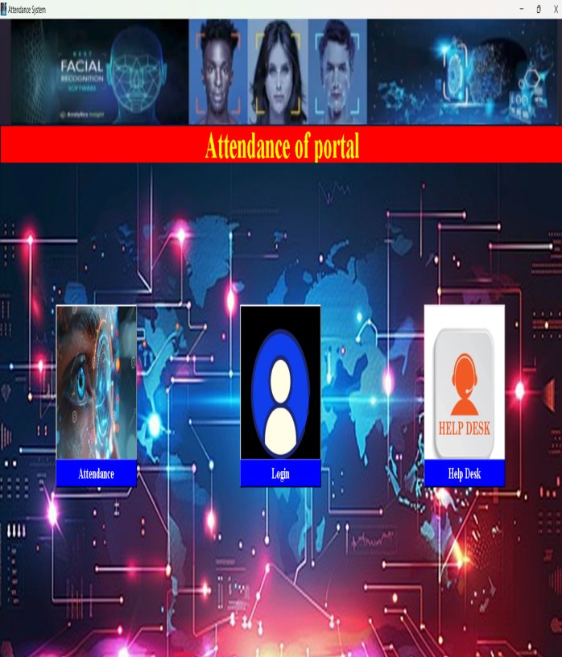 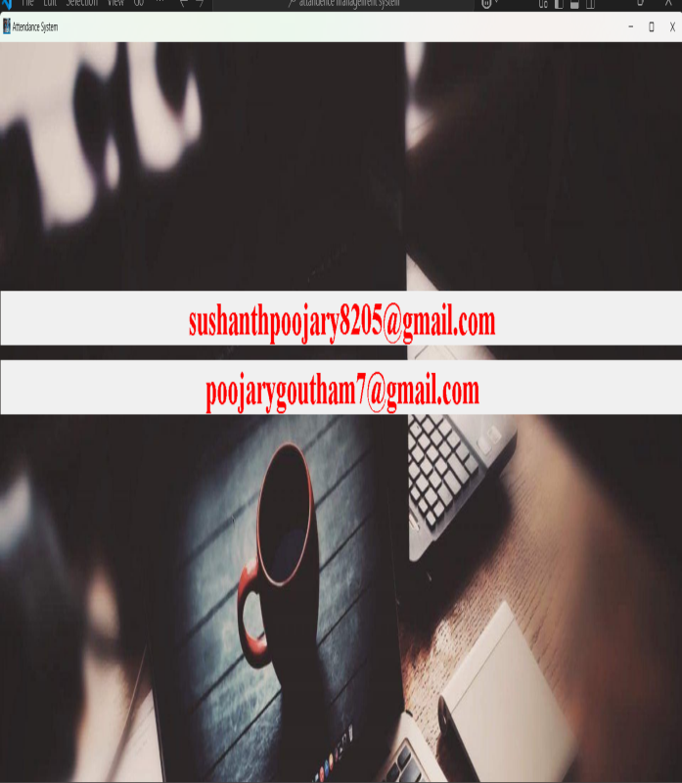

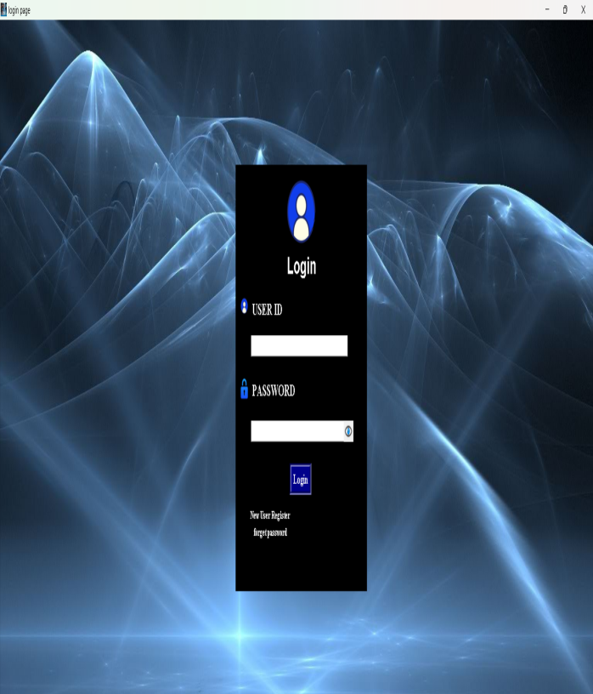 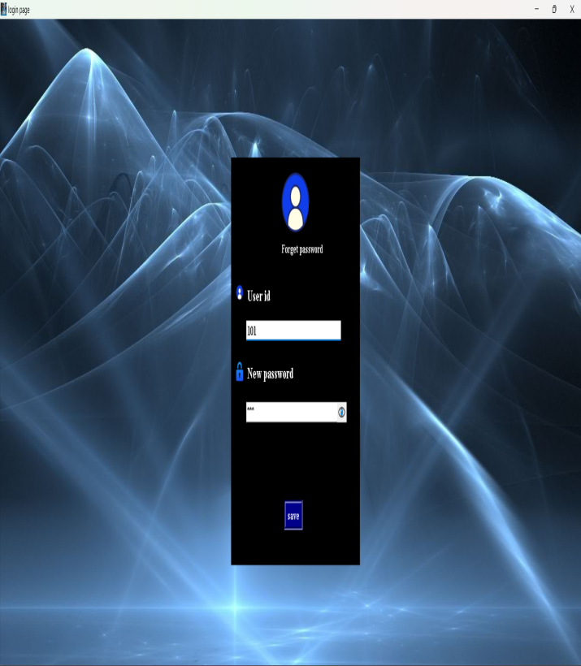

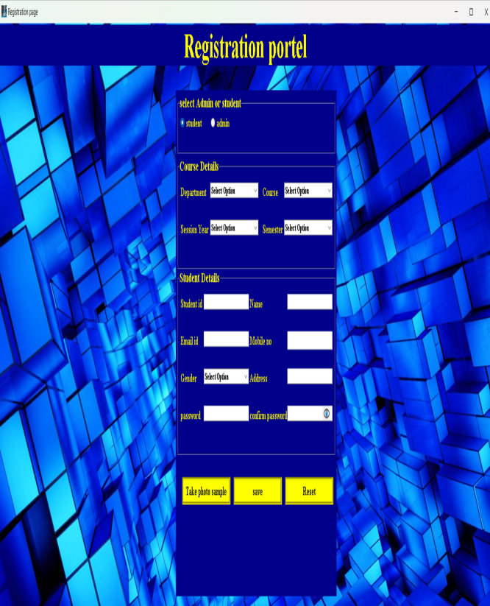 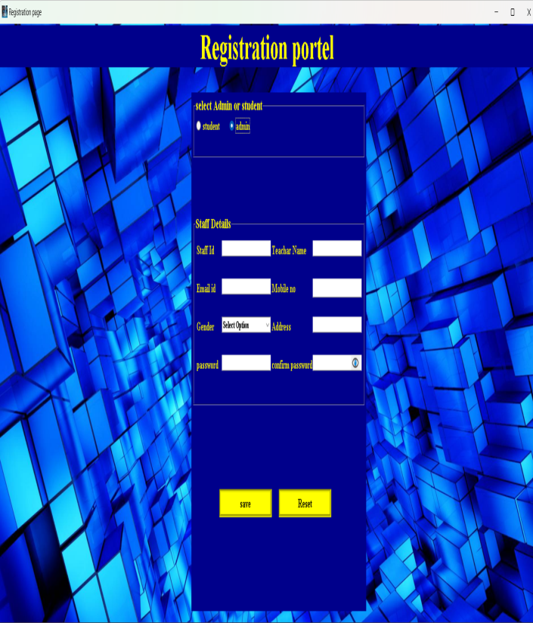

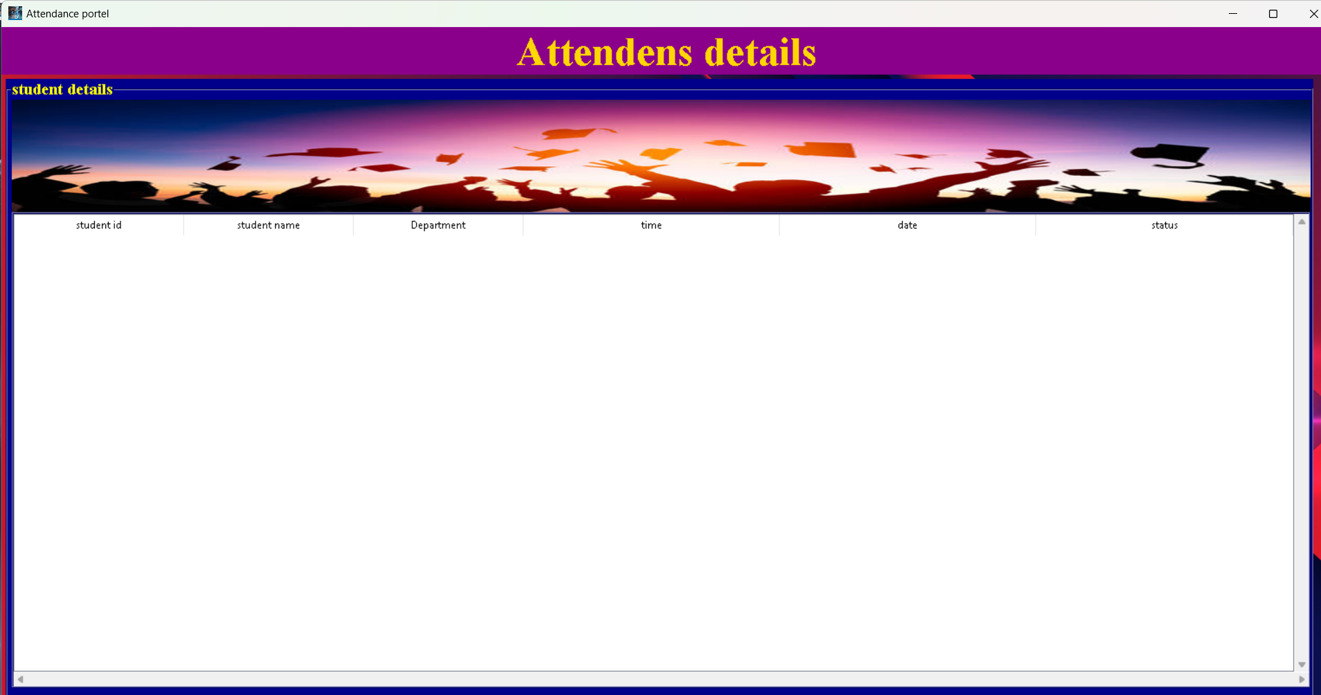

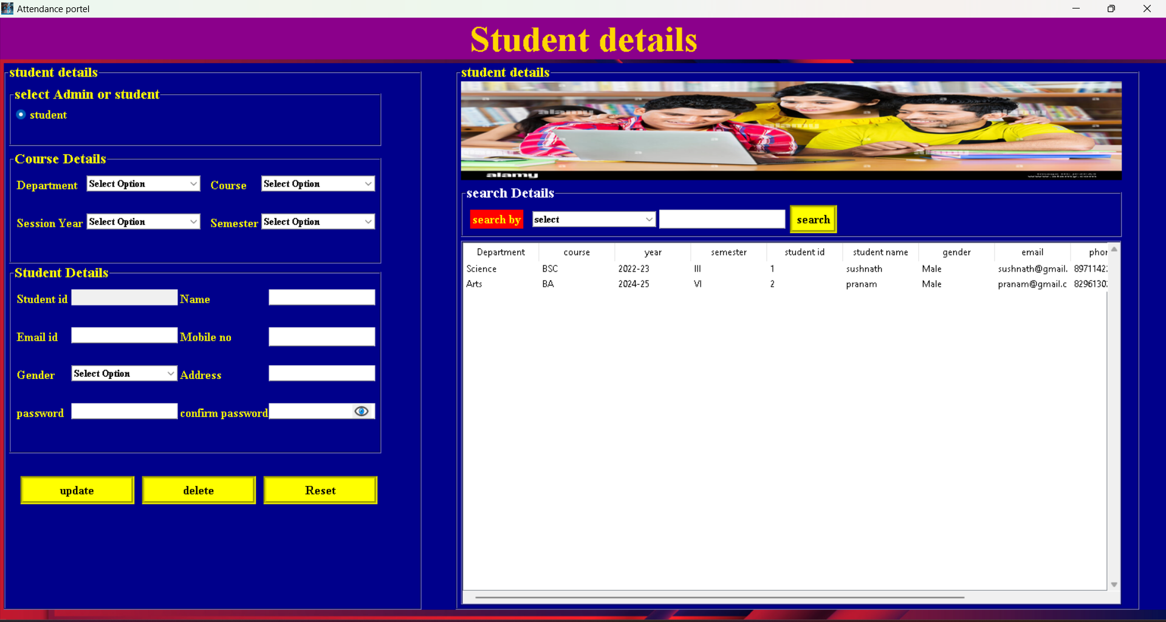

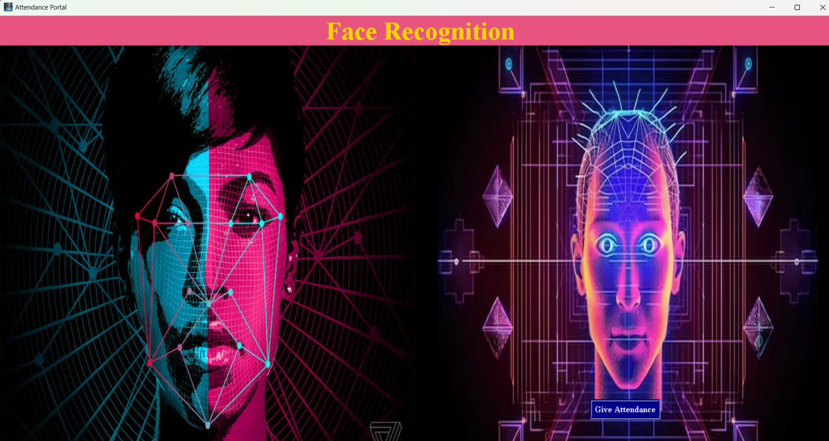

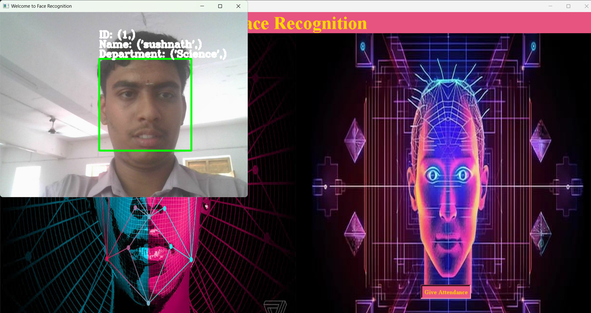

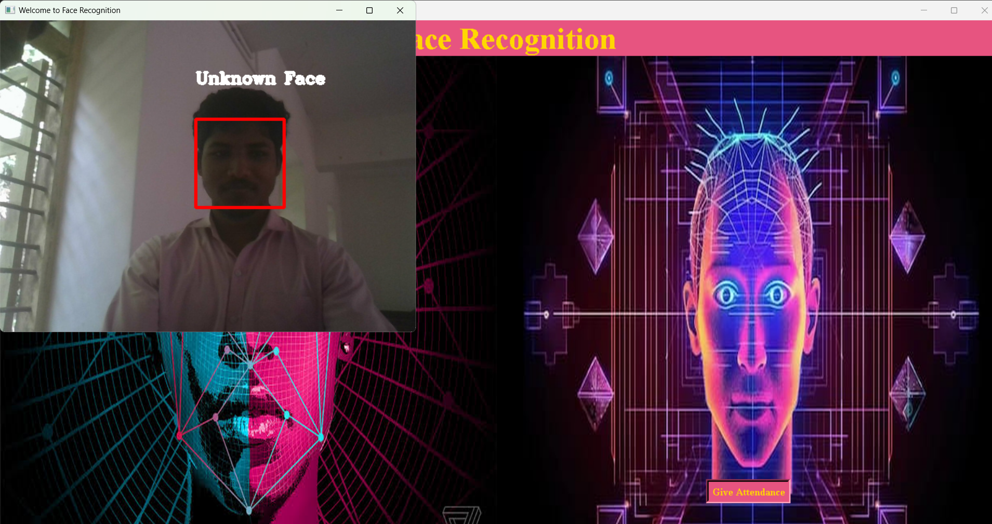

**Conclusion and Future Enhancement**

**Conclusion:**

The project was started with a lot of initiative and a good study was done and requirement specification was derived. This provides all the functionality as specified in software requirement specification. Once the requirement was frozen, the design and development were completed with data using ER diagram. Flexibility is provided for easy interface, understanding and future modification. After the development, the project is tested using unit testing method.

Future Enhancements:-

* Any modification can be done.
* Any fields can be added easily.

**Bibliography:**

* [**www.youtube.com**](http://www.youtube.com)
* [**www.w3schools.com**](http://www.w3schools.com)
* **copilot**
* **gemini**